API Manager

**1. What is API management?**

API management is the process of designing, publishing, documenting and analyzing APIs in a secure environment. Through an API management solution, an organization can guarantee that both the public and internal APIs they create are consumable and secure.

API management solutions in the market can offer a variety of features; however, the majority of API management solutions allow users to perform the following tasks:

* **API design** - API management solutions provide users – from developers to partners – the ability to design, publish and deploy APIs as well as record documentation, security policies, descriptions, usage limits, runtime capabilities and other relevant information.
* **API gateway** - API management solutions also serve as an API gateway, which acts as a gatekeeper for all APIs by enforcing relevant API security policies and requests and also guarantees authorization and security.
* **API store** - API management solutions provide users with the ability to keep their APIs in a store or catalog where they can expose them to internal and/or external stakeholders. This API “store” then serves as a marketplace for APIs, where users can subscribe to APIs, obtain support from users and the community and so on.
* **API analytics** - API management allow users to monitor API usage, load, transaction logs, historical data and other metrics that better inform the status as well as the success of the APIs available.

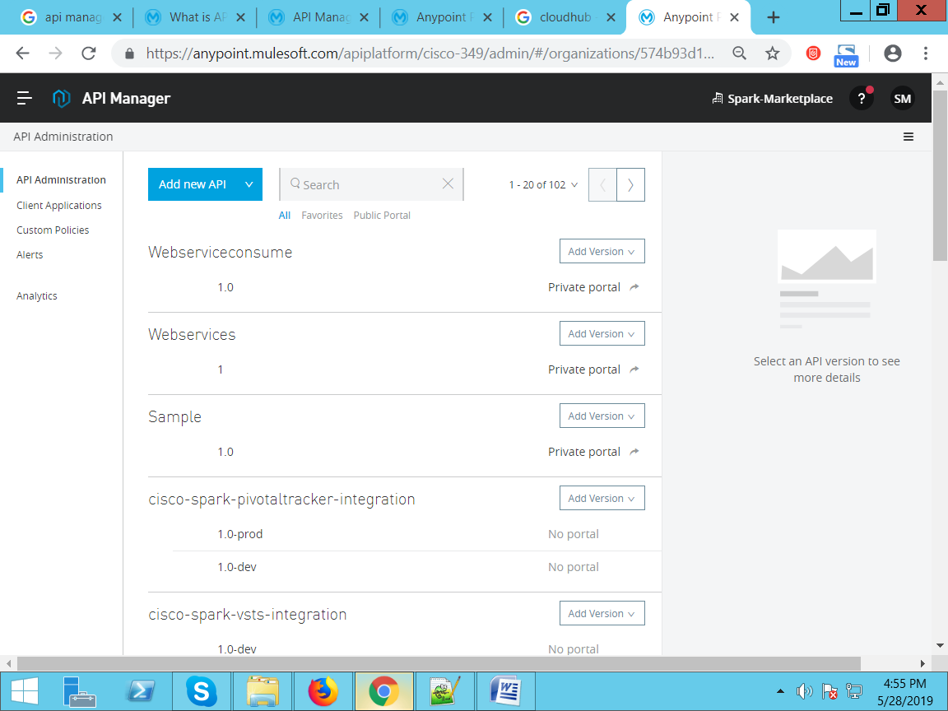

**2. What are the benefits of API management with Anypoint Platform?**

Anypoint Platform enables organizations to design, build and manage their integrations and APIs so they can modernize legacy applications, move to the cloud, create new products, integrate with Salesforce and SAP and much more.

Anypoint Platform includes an API management solution, Management Center, as well as the following capabilities:

* **Design Center** - An interface that offers low-friction development tools that make it easy to design APIs, compose integration flows and build connectors
* **Anypoint Exchange** - An API ‘store’ to save and share reusable assets such as APIs, connectors and templates publicly or privately within your organization.
* **Management Center** - A single unified API management web interface that allows users to administer all aspects of Anypoint Platform on-premises and in the cloud. Manage API users, traffic, SLAs, underlying integration flows and more.
* **Mule Runtime** - The runtime engine of Anypoint Platform. It combines real-time application integration and orchestration with robust data integration capabilities. Mule runtime is deployable as an on-premises integration engine, hybrid iPaaS, or API Gateway.
* **Anypoint Connectors** - These connectors provide quick connectivity to an endpoint or dynamic connectivity to API specifications.
* **Runtime Services** - This suite helps deliver enterprise-grade security, scalability, reliability and high availability.

**3. Objectives:**

Provide API management with Mule runtime engine, which includes a native API gateway. No matter where your APIs are hosted and which technologies they run on, you can view all your APIs in one place.

* Proxy existing services or secure new APIs with an API management gateway.
* Add or remove prebuilt or custom policies at runtime with no downtime.
* Deliver access management through tiered SLAs.
* Provision access across individual clients or entire teams with OAuth and SAML.
* Set alerts and respond proactively to mitigate policy and SLA violations.

Provide API management with Mule runtime engine, which includes a native API gateway. No matter where your APIs are hosted and which technologies they run on, you can view all your APIs in one place.

* Proxy existing services or secure new APIs with an API management gateway.
* Add or remove prebuilt or custom policies at runtime with no downtime.
* Deliver access management through tiered SLAs.
* Provision access across individual clients or entire teams with OAuth and SAML.
* Set alerts and respond proactively to mitigate policy and SLA violations.

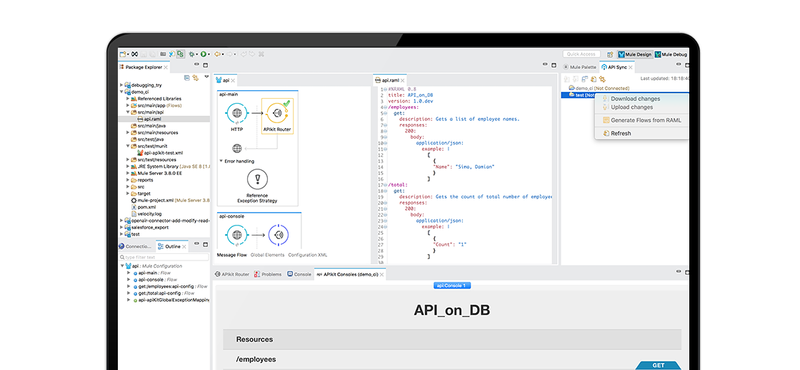

**Secure API gateway:**

Connect to any backend service or data source securely by deploying the Mule runtime engine as an API management gateway — whether it is in the cloud or on-premises. Proxy existing services or secure new APIs with a few clicks.

**Comprehensive policy library:**

Govern access to APIs and limit API calls with prebuilt or custom policies using little to no custom code. Add or remove policies for API security, throttling, rate limiting, and identity management at runtime with no downtime.

**Tiered SLAs:**

Provision users with different levels of access. Define multiple throughput limits in a single tier or across tiers to ensure quality of service (QoS) and make the limits visible or invisible to the client. With access management, assign API users to tiers manually or automatically.

**Integrated access management:**

Connect to PingFederate, Okta, LDAP, OpenAM, or MuleSoft's hosted identity management to provide secure access for developers, end users, and business groups. Leverage SAML integration to manage SSO and authorize API consumption through OAuth2 policies.

**Proactive alerts:**

Set up alerts on the status or performance of your APIs to trigger an email when defined events occur. Adjust resources proactively through alerts that notify you when policies are violated, users reach their API rate limit, or when applications approach SLA thresholds.